# CS 305 Module Two Coding Assignment Template

## Instructions

Replace the bracketed text with the relevant information in your own words. If you choose to include images or supporting materials, make certain to insert them in all the relevant locations in the document.

## Run Dependency Check

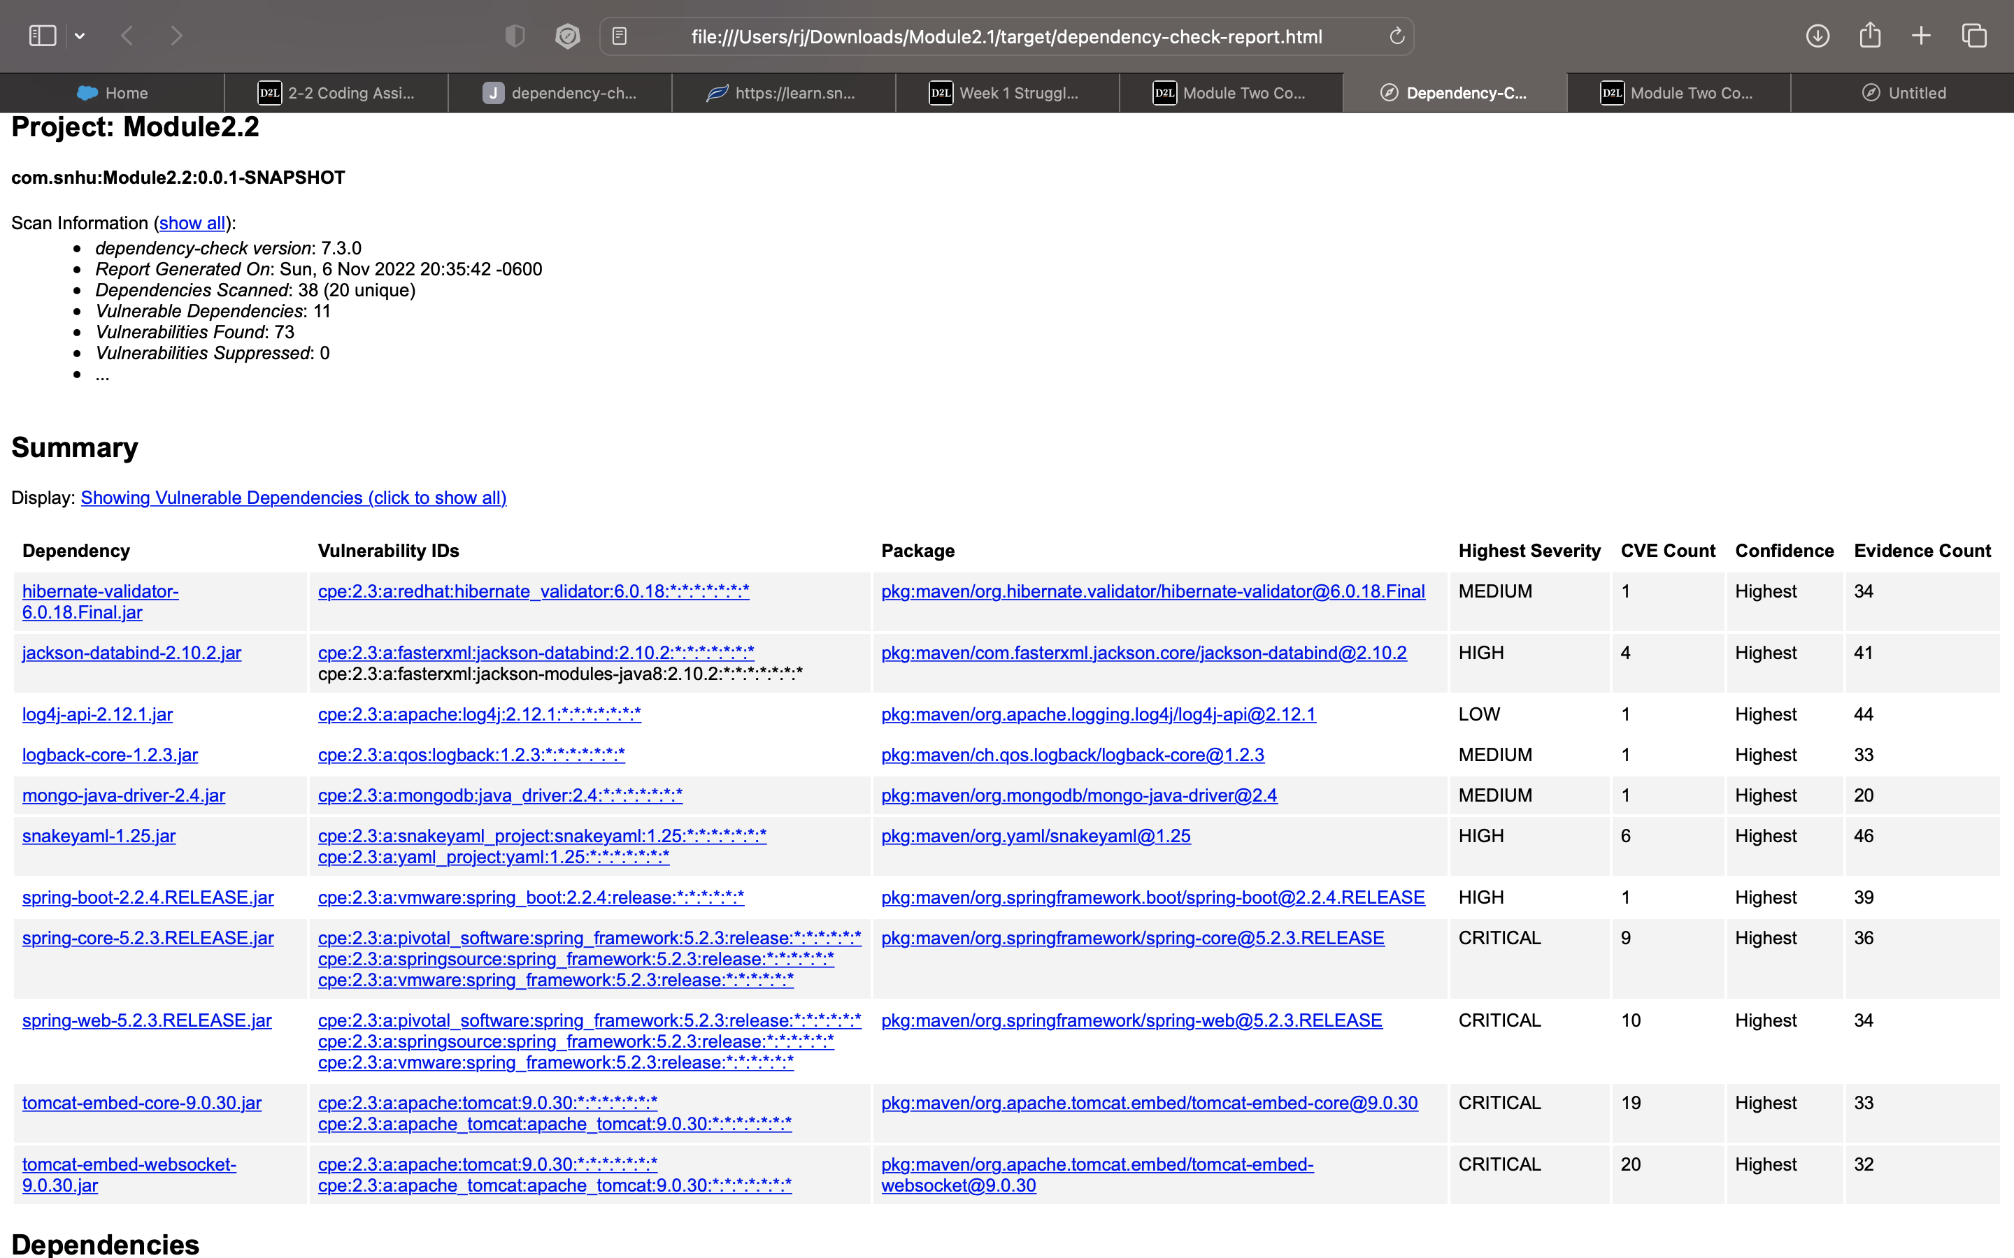

## Document Results

## CVE-2020-10693

A flaw was found in Hibernate Validator version 6.1.2.Final. A bug in the message interpolation processor enables invalid EL expressions to be evaluated as if they were valid. This flaw allows attackers to bypass input sanitation (escaping, stripping) controls that developers may have put in place when handling user-controlled data in error messages.

## CVE-2020-25649

A flaw was found in FasterXML Jackson Databind, where it did not have entity expansion secured properly. This flaw allows vulnerability to XML external entity (XXE) attacks. The highest threat from this vulnerability is data integrity.

## CVE-2020-9488

Improper validation of certificate with host mismatch in Apache Log4j SMTP appender. This could allow an SMTPS connection to be intercepted by a man-in-the-middle attack which could leak any log messages sent through that appender. Fixed in Apache Log4j 2.12.3 and 2.13.1

## CVE-2021-42550

## In logback version 1.2.7 and prior versions, an attacker with the required privileges to edit configurations files could craft a malicious configuration allowing to execute arbitrary code loaded from LDAP servers.

## CVE-2021-20328 (OSSINDEX)

Specific versions of the Java driver that support client-side field level encryption (CSFLE) fail to perform correct host name verification on the KMS server’s certificate. This vulnerability in combination with a privileged network position active MITM attack could result in interception of traffic between the Java driver and the KMS service rendering Field Level Encryption ineffective. This issue was discovered during internal testing and affects all versions of the Java driver that support CSFLE. The Java async, Scala, and reactive streams drivers are not impacted. This vulnerability does not impact driver traffic payloads with CSFLE-supported key services originating from applications residing inside the AWS, GCP, and Azure network fabrics due to compensating controls in these environments. This issue does not impact driver workloads that don’t use Field Level Encryption.

## CVE-2017-18640

## The Alias feature in SnakeYAML before 1.26 allows entity expansion during a load operation, a related issue to CVE-2003-1564.

## CVE-2022-27772

** UNSUPPORTED WHEN ASSIGNED ** spring-boot versions prior to version v2.2.11.RELEASE was vulnerable to temporary directory hijacking. This vulnerability impacted the org.springframework.boot.web.server.AbstractConfigurableWebServerFactory.createTempDir method. NOTE: This vulnerability only affects products and/or versions that are no longer supported by the maintainer.

## CVE-2022-22965

A Spring MVC or Spring WebFlux application running on JDK 9+ may be vulnerable to remote code execution (RCE) via data binding. The specific exploit requires the application to run on Tomcat as a WAR deployment. If the application is deployed as a Spring Boot executable jar, i.e. the default, it is not vulnerable to the exploit. However, the nature of the vulnerability is more general, and there may be other ways to exploit it.

## CVE-2016-1000027

Pivotal Spring Framework through 5.3.16 suffers from a potential remote code execution (RCE) issue if used for Java deserialization of untrusted data. Depending on how the library is implemented within a product, this issue may or not occur, and authentication may be required. NOTE: the vendor's position is that untrusted data is not an intended use case. The product's behavior will not be changed because some users rely on deserialization of trusted data.

## CVE-2020-1938

When using the Apache JServ Protocol (AJP), care must be taken when trusting incoming connections to Apache Tomcat. Tomcat treats AJP connections as having higher trust than, for example, a similar HTTP connection. If such connections are available to an attacker, they can be exploited in ways that may be surprising. In Apache Tomcat 9.0.0.M1 to 9.0.0.30, 8.5.0 to 8.5.50 and 7.0.0 to 7.0.99,

## CVE-2021-24122

When serving resources from a network location using the NTFS file system, Apache Tomcat versions 10.0.0-M1 to 10.0.0-M9, 9.0.0.M1 to 9.0.39, 8.5.0 to 8.5.59 and 7.0.0 to 7.0.106 were susceptible to JSP source code disclosure in some configurations. The root cause was the unexpected behaviour of the JRE API File.getCanonicalPath() which in turn was caused by the inconsistent behaviour of the Windows API (FindFirstFileW) in some circumstances.

## Analyze Results